Adventure works Order,Product sales,and customer reports

Introduction:
Transforming streams of raw data from around the globe about products, sales, and customers into a strategic tool to support business success. The company's CEO relies on you to provide insights that empower her to quickly and effectively understand the complex narrative of the company's performance.
Key Insights:
- Create a new dashboard
- Pin the live reports to the dashboard
- Add quick insights

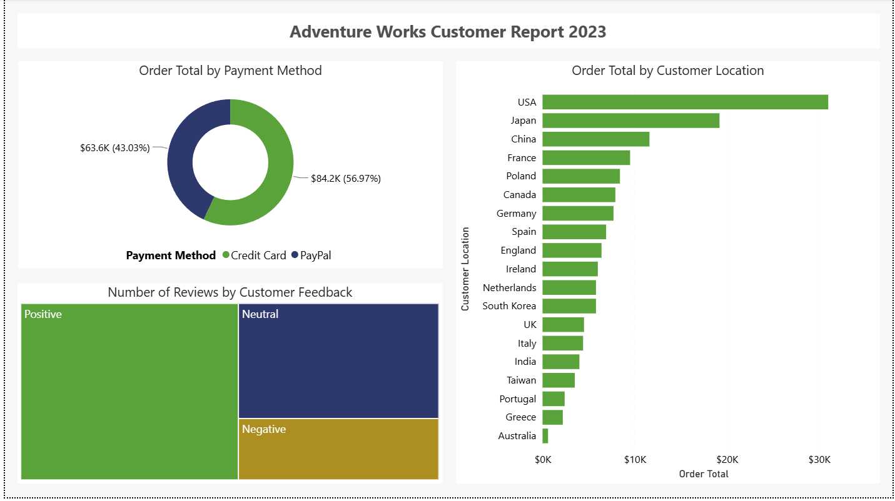
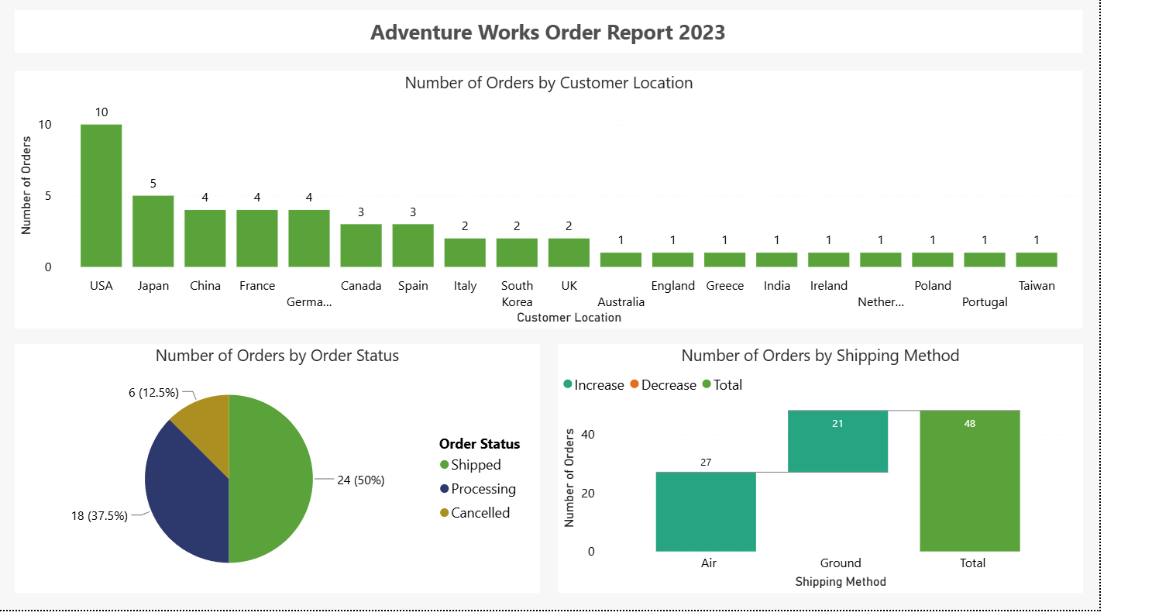

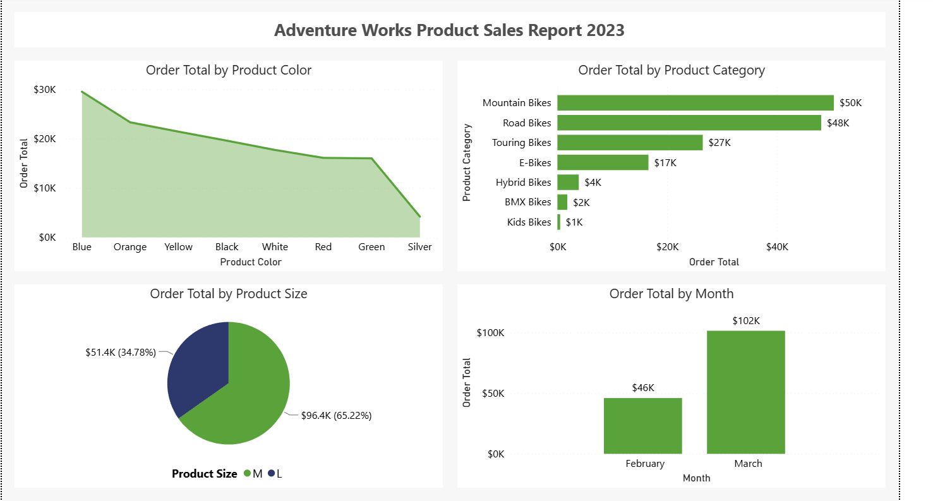

Conclusion:
Thus,refine various raw data sources into an executive summary dashboard for the Adventure Works CEO. Converting raw data into dynamic, intuitive dashboards full of quick insights is a vital skill that can help guide critical business decisions.

